SEPARATE Biology Required Practical revision pack
Name:_________________________________
This is the list of required practicals you will need to know about for your biology exam.
At least 15% of the marks of the marks in your exams may be on these!
 | Title | Page | Details of practical | Tick when completed
PAPER 1 | Microscopy | 2 | Use a light microscope to observe, draw and label a selection of plant and animal cells. A magnification scale must be included.
 | Osmosis | 4 | Investigate the effect of a range of concentrations of salt or sugar solutions on the mass of plant tissue.
 | Enzymes | 6 | Investigate the effect of pH on the rate of reaction of amylase enzyme. Pupils should use a continuous sampling technique to determine the time taken to completely digest a starch solution at a range of pH values. Iodine reagent is to be used to test for starch every 30 seconds. Temperature must be controlled by use of a water bath or electric heater.
 | Food Tests | 9 | Use qualitative reagents to test for a range of carbohydrates, lipids and proteins. To include: Benedict’s test for sugars; iodine test for starch; and Biuret reagent for protein.
 | Microbiology | 13 | Investigate the effect of antiseptics or antibiotics on bacterial growth using agar plates and measuring zones of inhibition.
 | Photosynthesis | 16 | Investigate the effect of light intensity on the rate of photosynthesis using an aquatic organism such as pondweed.
PAPER 2 | Reaction time | 18 | Plan and carry out an investigation into the effect of a factor on human reaction time.
 | Plant responses | 20 | Investigate the effect of light or gravity on the growth of germinated seedlings. Record results as both length measurements and as careful, labelled biological drawings to show the effects.
 | Field investigations | 22 | Measure the population size of a common species in a habitat. Use sampling techniques to investigate the effect of a factor on the distribution of this species.
 | Decay | 25 | Investigate the effect of temperature on the rate of decay of fresh milk by measuring pH change.

Microscopy required practical
Microscopes allow us to see small objects like cells in more detail, so we can see the sub-cellular structures, like chloroplasts. Link to video https://www.youtube.com/watch?v=mMHtHzAZrxs
Or search ‘microscopy GCSE core practical AQA you tube’. Read about the experiment in your exercise book or text book.

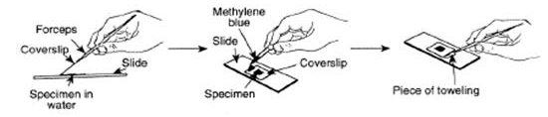

Method
- Use a stain to make things visible (cell wall, nucleus).
- Get the specimen as flat and thin as possible to allow light through so you can see the cell structures and so that the cells aren’t piled on top of each other (which makes them unclear).
- Start on the smallest lens, focus, then move up a lens: this makes it easier to focus.
- a ruler, or eyepiece scale (graticule) can be used to measure size
1. Do a biological diagram of an animal cell below:

Make sure you know the units:
1mm = 1000um
1um = 1000nm

Remember! Use a pencil and simple lines, a ruler and a scale bar. Assume 50 mm = 100μm

To work out magnification of an image (what you see under the microscope):
Magnification = ___image size____
actual object size

2. Fill in the table (NB look carefully at the units!):
Magnification | Image size | Actual size | Use this unit for actual size
 | 100mm | 10mm
X200 | 100mm |  | mm
X1000 | 100mm |  | Microns (μm)
 | 100mm | 25 μm
X400 | 50mm |  | nm

3. (HT question): Now calculate the volume of a nucleus, given that you have measured the diameter of it using the graticule and it is 5 μm. Volume = $\frac{4}{3}$ π r² Assume π =3.14 and give your answer to 1 decimal place.

4. Exam style questions
  - Explain why we can see the nucleus and cell wall but not the mitochondria.
  - How can we see smaller parts of cells (subcellular structures)?
    - (answer: they’re far too small and not stained)
    - (answer: Use an electron microscope which has much higher resolution and magnification, although the specimen has to be dead.)

2) Answers to magnification table
Magnification | Image size | Actual size | Use this unit for actual size
X10
 |  | 0.5mm
 |  | 100μm
X4000
 |  | 125,000
3) HT question. Volume = 34.7 μm³

Required practical: osmosis
Start by watching this youtube video: https://www.youtube.com/watch?v=G5qSzWGFM1Y&list=PLqIkHVv4dzo77CpodecFqxl8vMS6dHwFr&index=2
Or search ‘osmosis GCSE core practical AQA you tube’. Read about the experiment in your exercise book or text book.
OSMOSIS DEFINITION= The diffusion of water down its gradient, ie from where there is more water to where there is less water, across a partially permeable membrane. So water goes from a dilute (watery) solution to a concentrated (sugary / salty) solution.
Summary: We put potato cores in solutions which had different strength sugar solution in them. In the test-tubes which had very watery solution (dilute), the water went into the potato cells, making them grow longer / heavier. In tubes where the solution was very sugary (concentrated), there was more water in the cells than the solution, so water moved across the cell membrane (partially permeable) out of the potato cells, meaning that the cells got shorter / grew lighter.

The apparatus is set up like this (remember it can be salt or sugar):
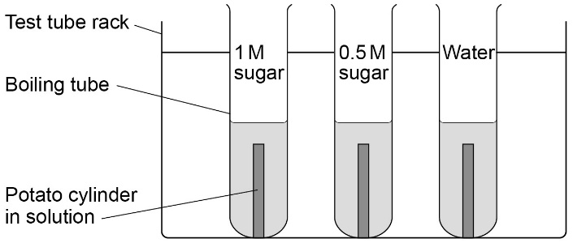

This is what happens to the cells in different concentrations:
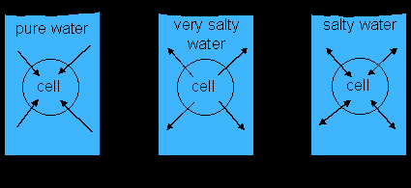
Remember: ANY plant cell will take in water if it is in a more dilute solution than the cell. Any plant cell will lose water when put into a concentrated solution too. So if you put strawberries in sugar, the water will leave the strawberries and go into the sugar (it makes a tasty syrup).

Exam questions will be on these areas (answers below)
- What are the variables?
- Why blot the potato dry before weighing?
- Why doesn’t the sugar / salt move through the membrane?
- How could you make your measurements more precise?
- How could you improve your experiment’s repeatability?
- Where on a graph can you find the concentration of the cell?

- Answers: Control variables: these are everything we keep the same: temperature, potato variety, volume of liquid
Dependent variable (DIM, Dependent I Measure) = length / mass of potato core
Independent variable (IIC, Independent I Change) = concentration of sugar / salt solution
- Water on the potato adds mass so needs to be dried off to improve accuracy of results
- The sugar / salt molecules are too big to move through the membrane (only the water can move)
- The smaller the unit used to measure, the more precise. So mm is more precise than cm. Mg is more precise than g.
- Repeatability is to do with repeating your experiment and getting similar results
- The concentration of the cells is where there is NO INCREASE OR DECREASE IN SIZE / MASS OF THE POTATO. You can see it on your graph from the best fit line.

Now try and write out the definition of osmosis from memory

Now it’s time to do an exam question…

Effect of temperature on enzyme activity – required practical revision
We carried out our practical investigation using temperature as our independent variable.
Watch a reminder of the experiment https://www.youtube.com/watch?v=sVWNp8zHrKU (effect of temperature)
You could be asked how you would investigate the effect of pH as the independent variable. The technique you use is the same – iodine on the breakdown of starch. Watch a video here https://www.youtube.com/watch?v=JyXXoevEWc8
Starch sugar

We can measure the rate of any enzyme reaction in 2 ways
- How quickly a product is made eg sugar
- How quickly a reactant is broken down. eg starch

- Fill in the gaps
The rate of reaction is measured by timing how long it takes for s_______ to be b______ d_____ by the enzyme a_________ into s________.
Iodine turns b___/b_____ if starch in present. When all the starch has been used up, the iodine will stay an o________ colour.
The faster the rate of reaction of amylase, the l____ time it will take for all the s_______ to be broken down. This means that it will take less time for the iodine to return to an o_________ colour.
amylase
Key words – can you define each one and use it correctly in a sentence?
enzyme starch amylase
sugar denatured active site kinetic energy
Summary of method
- Measure 5cm³ of starch into a test-tube and 2cm³ of amylase into a separate test tube.
- Heat to the required temperature in a water bath. Leave until each solution has reached the required temperature.
- Mix the 2 solutions together but keep in the water bath. Immediately and then every 30 seconds use a pipette to take a drop of the mixture and place on a dropping tile you have previous filled with drops of iodine.
- Record the time taken for the iodine to return to an orange colour. This will be the time taken for all the starch to be broken down into sugar. Repeat at different temperatures.
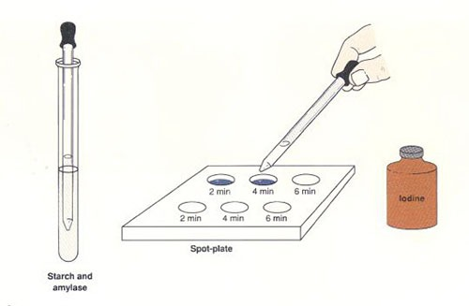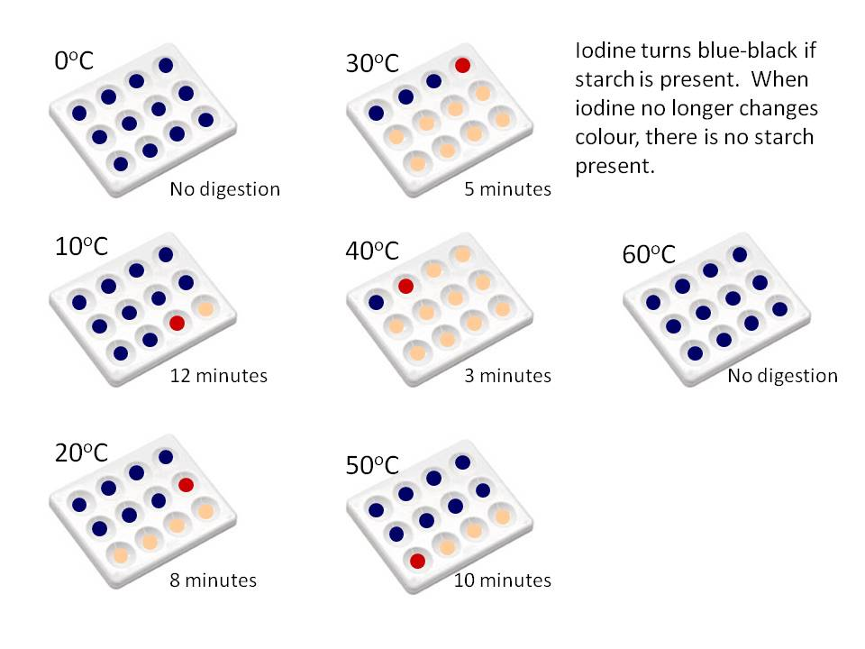
B: What do these results show?
- Which temperature had the fastest rate of reaction?_______________
- Explain why the rate of reaction increased from 0ºc to your answer above.
- Which two temperatures had no reaction?
________ and _________.
- Explain the reasons why these two temperatures showed no reaction. (different reason for each temperature!)

C: Exam style questions
- Why should you heat both the enzyme (amylase) and starch to the required temperature separately before you mix them?
- Explain 2 different ways you could heat up and maintain the solutions at the right temperature. Which way is best?
- Do the results above prove the optimum temperature for amylase is 40ºc? Explain your answer.
- How could you improve the experiment to try to find the optimum temperature for amylase?
- List as many control variables as you can.
- How would you check the repeatability of your results?
- How would you check the reproducibility of your results?
- What possible sources of error could there be in this experiment? How could you minimise each one?
- Why is it easier to use the starch test to measure the disappearance of starch rather than the Benedict’s test to measure how quickly sugar is produced? (HIGHER TIER)
Answers
A: Gap fill: starch, broken down, amylase, sugar, blue/black, orange, less, starch, orange.
B: What do these results show?
- 40ºc
- As temperature increases, particles move around faster (have more kinetic energy) so starch and amylase more likely to collide/bump into each other. More active sites on the enzymes are filled with starch so reaction gets faster.
- 0 ºc and 60 ºc
- 0 ºc – too cold – starch and amylase have very little kinetic energy (do not move around enough) to bump into each other, so no reaction. The enzymes has NOT been denatured.
60 ºc – the high temperature has DENATURED the enzyme – changed the shape of the active site on the enzyme so the starch no longer fits. No starch can be broken down. This is an irreversible change.
C: Exam – style questions
- To make sure both solutions are at the required temperature so the reaction is carried out at the temperature you require. This improves the accuracy of the experiment.
- Electric water bath – maintains an even temperature (thermostat to automatically control temp), no human control needed, minimal temp fluctuations – BEST METHOD!
Water bath using beaker of water and Bunsen burner – harder to maintain at a steady temperature, requires constant human input and monitoring with a thermometer.
- No; only tested every 10 ºc so the optimum temp may be between these intervals. Ie 38 ºc or 44 ºc. 40 ºc is the fastest temperature of those that were tested.
- Test with smaller intervals of temperature eg every 1 or 2 ºc
- pH, volume of starch, concentration of starch, volume of amylase, concentration of amylase (don’t say amount……), volume of solution removed to test, concentration of iodine, amount of mixing.
- You doing the exact same experiment again and getting a similar pattern of results. (results do not need to be exactly the same)
- Someone else doing your experiment or following a slightly different method and getting a similar pattern of results to you.
- Inaccurate measurement of volumes of solutions (use smallest volume syringe to measure), solutions not at correct temperature before mixing (measure temp with a thermometer to check), not mixing solutions evenly (use pipette to constantly stir gently once mixed), people disagreeing on iodine colour change (use same person to decide each time)
- Iodine test for starch is a simple, one step reaction that doesn’t need any heating so you get results instantly. Only need a dropping tile and pipette – simple equipment. Benedict’s test for sugar needs heating to 85 in a water bath for 2 minutes so have to wait for results and uses more complex equipment.
Now have a go at the past exam questions based on this topic!

Required Practical: Food tests
In this investigation, we used qualitative reagents to test for carbohydrates, lipids and proteins. These included: Benedict’s test for sugars; iodine test for starch; Biuret reagent for protein. We also used Sudan lll to test for lipids (fats).
Start by watching this youtube video: https://www.youtube.com/watch?v=zbZxFxXN6m4
or search “food tests GCSE core practical AQA you tube”. Read about the experiment in your exercise book or text book (pg41). You will also find this on pg 18 in the separate science revision guide and pg 26 in the combined revision guide.
What is the point of the practical?
You are trying to find out if particular foods contain sugars, starch, proteins or fats.
Obtaining the filtrate
Before you carried out the food tests, you were required to produce a filtrate of each of the food samples.
To do this, you use a pestle and mortar to grind up the food. You then add a small amount of water. You fold a piece of filter paper and put this into a funnel. Put the funnel onto the top of a test tube and pour the contents of the mortar into the funnel. The liquid in the test tube is the filtrate. This is the liquid that is used to carry out the food tests.
Below is a reminder of the method for each of the tests.
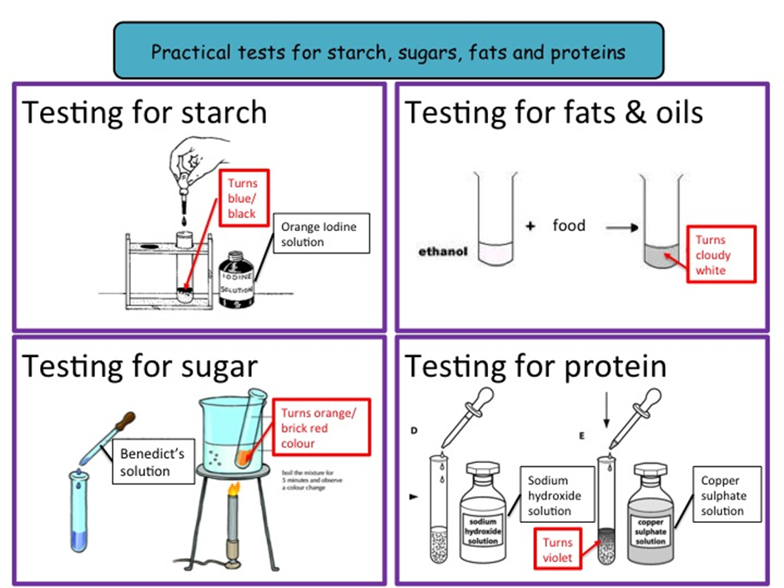
In the practical we used Sudan lll to test for the lipids. Sudan lll is a red liquid. It is added to the food sample in the test tube. If fat is present, a red layer will settle at the top after the sample has been gently shaken.
Food test | Name and colour of chemical added | Colour change in the sample for a positive test
Sugar
Starch
Protein
Fat

Now write out the method for each of the tests using the diagrams and your revision guide as prompts. Use the space below.
Food test | Method
Test for sugars
Test for starch
Test for protein (Biuret test)
Test for lipids (fats) using Sudan lll

Now answer these questions:
1.What is the independent variable?

2.What is the dependent variable?

3.What are the control variables here?

4.State the role of amylase in digestion.

5.Suggest and explain why the colour of the solution (after Benedict’s solution has been added) can be used by diabetes sufferers.

Exam hints
Always remember to say that the Benedict’s reagent must be heated to 90’C to obtain results.
Always refer to iodine solution rather than iodine.
In the Biuret test for protein, the purple colour can be difficult to see so hold the test tube in front of a sheet of white paper.

Risk assessment
You may be asked about any hazards and risks (eg reagent is an irritant if it gets in your eyes) involved in this practical (harmful things that might happen) and control measures (what you did to reduce the risk, eg wearing goggles). This is called a risk assessment.
Fill in the table below to complete a risk assessment for this practical. An example has been completed to help you.
Hazard | Risk | Control measure
Eg bags on floor. Someone might trip over a bag and injure themselves | Medium | Put bags securely under the desk

Answers
Food test | Method
Test for sugars | Put 2 cm² filtrate into a test tube.  Add the same amount of Benedict’s solution.  Place in a waterbath (at about 85⁰c) for five minutes.  Brick red colour shows positive results for sugar
Test for starch | Add 5ml of filtrate into a dimple tile.  Add up to 5 drops of iodine solution.  Blue black colour indicates the presence of starch
Test for protein (Biuret test) | Add 2cm³ of filtrate to a test tube.  Add 1cm³ Sodium Hydroxide.  Add Copper Sulphate solution one drop at a time. Watch for a colour change.
Test for lipids (fats) using Sudan lll | Add 5cm³ of filtrate to a test tube.  Add 10 drops of Sudan lll.  Gently shake test tube.  If the Sudan lll mixes with the food it will form a red layer at the top of the filtrate showing a positive result.
Answers.
- Chemical used.
- Colour change in food sample (filtrate)
- Use filtrate from same food sample each time. Use a thermometer to control the temperature.
- Amylase is produced to break down carbohydrates into simple sugars (like glucose)
- Diabetics cannot control their blood glucose concentrations. They need to control the amount of carbohydrates that they consume because carbohydrates are made up of simple sugars like glucose. A colour change will indicate the presence of simple sugars like glucose. The range in colours of the results from pale yellow to brick red give a qualitative indication of the amount of sugars present in the food sample.
Hazard | Risk | Control
Getting chemicals in your eyes | High | Wear goggles
Burning hands on hot water in the waterbath | Low risk | Use test tube holders when taking test tubes in and out of waterbath
Tripping over stools or bags in the lab | Medium | Tuck stools in.  Stow bags under benches.

Microbiology practical revision (separate)
https://www.youtube.com/watch?v=Fd44VxSH2O8 or search for ‘microbiology GCSE core practical AQA youtube’. Read about the experiment in your exercise book or text book.
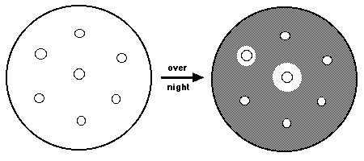
Brief method:
Agar with one species of bacteria growing in it is poured into a petri dish. It is left to set and then antibiotic (or antiseptic) – covered discs are put onto the agar. Where bacteria are growing, it looks cloudy. The antiseptic diffuses out into the agar, killing the bacteria, making it look clear. This killing zone is called the ‘zone of inhibition’. If the bacteria are not killed by the antiseptic (eg if they are resistant), then the bacteria grow all the way up to the disc (it stays cloudy).

Method | Reason for this step
Use sterile petri dishes

Wash your hands before the experiment

Wipe bench with disinfectant before
experiment
Flame neck of agar bottle before pouring agar

Letting agar jelly sit for 5 minutes before putting antibiotic disc on

Turn Bunsen to orange flame

Use the same size antibiotic discs each time

Only use 2 pieces of sellotape to allow air in

Incubating bacteria culture at < 25’C

Disinfecting bench after practical

Risk Assessment
Hazard | Risk | Control measure
Bacteria (pathogenic ie harmful) | Infection to you | Incubate at no higher than 25’C (lower than body temp so pathogens won’t grow)

Work through the problems in this table:
The formula for area is: Area = π r²
Assume π = 3.14 and give your answer to 1 decimal place. You must give correct units (mm²).

 | Antibiotic A | Antibiotic B | Antibiotic C | Antibiotic D
Diameter of zone of inhibition (mm) | 6 | 10 | 0 | 5
Area of zone of inhibition (you write the units)
Number from most to least effective antibiotic
Which one has resistant bacteria?

Question: How does antibiotic resistance increase in a population of bacteria? (4 marks)

Answers:
 | Antibiotic A | Antibiotic B | Antibiotic C | Antibiotic D
Diameter of zone of inhibition (mm) | 6 | 10 | 0 | 5
Area of zone of inhibition (you write the units) | 28.3 mm² | 78.5 mm² | 0 mm² | 19.6 mm²
Number from most to least effective antibiotic | 3 | 4 | 1 | 2
Which one has resistant bacteria? |  |  | This one
Answer to question: How does antibiotic resistance develop in a population of bacteria? (4 marks)
You need to use VSRG in this question. There is variation in the amount of resistance in the population. The resistant bacteria are selected for and more survive. They reproduce more, passing on the genes for resistance.

Light intensity in Photosynthesis required practical revision

Start by watching these clips:
You Tube clip explaining some of the key principles of the Required Practical.
https://www.youtube.com/watch?v=hITp-60mqzg
Programme simulating the effect of light intensity on photosynthesis.
- https://www.reading.ac.uk/virtualexperiments/ves/preloader-photosynthesis-full.html

Summary
In this Required Practical we are investigating light intensity as a limiting factor in photosynthesis. As light intensity increases, the rate of photosynthesis will increase as long as other factors eg water are in adequate supply. As the rate increases, eventually another factor will come into short supply eg CO2 concentration, and this will limit the rate of photosynthesis.
Set up this simple equipment:
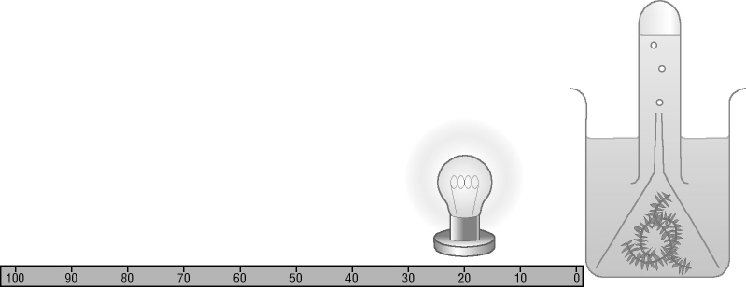
- Position your bench lamp a measured distance from the beaker. Record.
- Allow two minutes for the pondweed to adjust to the light intensity.
- Count the number of bubbles released over a one-minute period.
- Repeat for a second one-minute period.
- Move the lamp 10 cm further away and repeat steps 1 to 4.
- Continue at further intervals of 10 cm up to 50 cm.
- Record your results in a table:
- Plot these results as a line graph.
- Try to explain any pattern you see in the results.

Key points to consider
- What are the HAZARDS and CONTROL MEASURES (things we did to minimise the hazards)?
- How you could improve the accuracy, repeatability, reproducibility, reliability, and precision of your investigation?
- How do you deal with an anomalous results?

Analysis of results
Distance (d) (cm) | d ² | light intensity  100/d² | Number of bubbles per minute
10 | 100 | 1 | 34
20 | 400 | 0.25 | 22
30 | 900 | 0.10 | 15
40 | 1600 | 0.06 | 9
50 | 2500 | 0.04 | 6

Questions
1. What are the independent, dependent and a major control variable in this investigation?
2. What is the pattern shown in these results?
3. Estimate the number of bubbles at light intensity 0.2.
4. What is the rate of number of bubbles per light intensity increase between 0.1 and 0.2 light intensities?
5. What is the biological explanation of these results?
6. Some bicarbonate indicator was added to the water surrounding the Elodea. Why would this benefit the plants?
Answers
- Independent = distance from the lamp. Dependent= number of bubbles per min. Main control variable = temperature. Others: plant size, age, species. Wattage of lamp.
- As light intensity increases the number of bubbles also increases.
- 20.
- 5/0.1 = 50 bubbles per unit of light intensity.
- As the light intensity increases so does the rate of photosynthesis. This produces oxygen which is why there is an increase in the number of bubbles of gas observed coming out of the water plant.
- The bicarbonate indicator would supply extra carbon dioxide. This higher concentration of carbon dioxide would enable a faster rate of photosynthesis and a faster production of oxygen. Now it’s time to do an exam question…..
Human reaction time required practical revision
Watch the Youtube video https://www.youtube.com/watch?v=Sqd7QG__Xi0
(or search ‘you tube required practical GCSE ruler drop’)
Learn the method used.

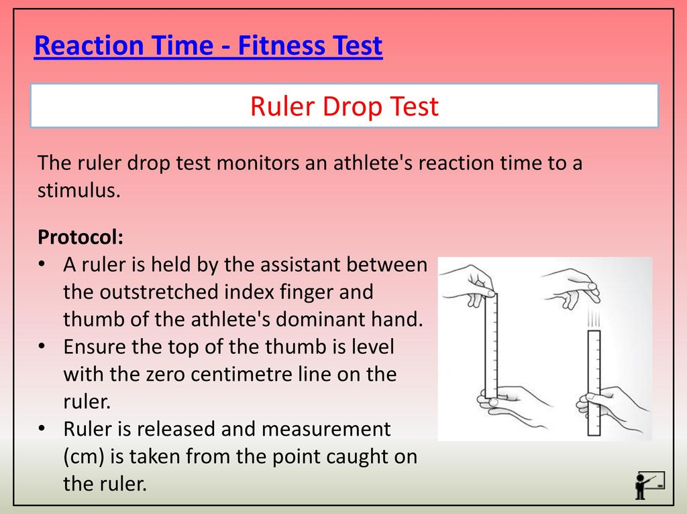
Note - you can use a conversion table to convert cm into the time taken to react.

- Describe the effect caffeine has on the human body.

- Name the independent variable.

- Name the dependent variable.

- The control experiment was the people without caffeine. The purpose of a control experiment is to…

- Examples of variables that were controlled (this is different to the control experiment) were: age, (think of 2 others) …………..

- What is the biggest source of error in this experiment?

- What is a blind trial and what is its purpose?

- Label the sketch graph with the axes you would use for this experiment.
- Draw bars to show the trend for the results you would expect to get.

Answers
- Describe the effect caffeine has on the human body. It decreases reaction time
- Name the independent variable. Whether someone has caffeinated coke or decaff coke.
- Name the dependent variable. Reaction time to catch ruler.
- The control experiment was the people without caffeine. The purpose of a control experiment is to Have a baseline measurement against which you can compare the experiment – so any effect you see is definitely the independent variable (in this case the caffeine).
- Examples of variables that were controlled (this is different to the control experiment) were: age, (think of 2 others), volume of liquid drunk, time after drinking the reaction time was measured, the activity, the number of ‘practise goes’, temperature of room, light levels in room
- What is the biggest source of error in this experiment? Pupils are different sizes, they might have had caffeine earlier, they might be used to caffeine, their body may process it at a different rate because of natural variation
- What is a blind trial and what is its purpose? Blind trials remove any psychological effects that may interfere with the results, eg if you think you have or haven’t taken caffeine this might in itself affect reaction time. Double blind means that neither the person being experimented on nor the scientist knows until the end which one had the caffeine.
- Graph axes: x axis = treatment (caffeine/ no), y axis = reaction time (or number of cm it took to catch the ruler)
- The bar would be expected to be lower for caffeine.

Required practical: Field Investigations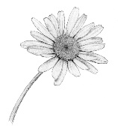
Start by watching this YouTube video: https://www.youtu be.com/watch?v=KlC-qPpQEgA
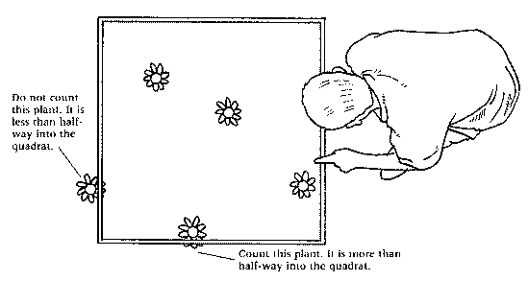
Equipment
- a 1 m² quadrat
- a 30 m tape measure
- a clipboard
- a pen
- paper

The aim of this investigation is to measure the population size of a common species in a habitat. You should be able to use sampling techniques to investigate the effect of a factor on the distribution of this species.
There are lots of different factors that could be investigated. We investigated the effect of light intensity on the abundance of daisies by setting up a transect that started underneath the shade of a tree, like the one below, and counting the number of daisies in our quadrat at regular intervals. We found that as the light intensity increased, the number of daisies increased. Why do you think this is? Hint: why do plants need light?

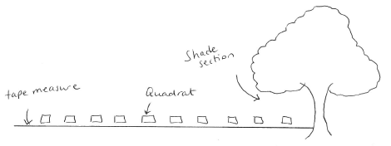
Answer: plants need light to photosynthesis and grow. When light intensity is greater, they can photosynthesise more and grow more.

Below is data similar to that which we collected.

Distance along transect / m | Light Intensity / Lux | Number of daisies
 |  | Transect 1 | Transect 2 | Transect 3
0 | 100 | 2 | 0 | 1
5 | 100 | 1 | 3 | 1
10 | 480 | 3 | 3 | 2
15 | 1000 | 3 | 12 | 2
20 | 1750 | 5 | 4 | 3
25 | 2250 | 7 | 8 | 6
30 | 2800 | 7 | 7 | 6
35 | 3100 | 9 | 10 | 12
40 | 3800 | 10 | 12 | 11

- Could you explain why the circled number is an anomaly? It is because it does not fit the pattern.
- The mean number of daisies found 20 m along the transect is 4. How was this calculated? (5+4+3)/3. Remember not to include any anomalous results when you are calculating a mean.
- The median light intensity is 1750 Lux, this is the middle value in an ordered list of data (if you have an even number of values, divide the two middle values by 2, that will be your median)
- The mode is the value that occurs most frequently. Can you find the mode for the number of daisies? Answer: it is 3.
Questions
- Light intensity is an example of an abiotic factor, what is an abiotic factor? Give three more examples of abiotic factors that could affect the distribution of plants.
- In our investigation we used a transect, explain how to set up a transect.
- Some fieldwork investigations require a random sample. Why is it important that a sample is random? How would you carry out a random sample?
- We measured the light intensity using a light meter, why was it important that we took all of our readings at approximately the same time?
Answers
- An abiotic factor is a non-living factor that affects living organisms. Examples other than light intensity are: temperature, moisture levels, soil pH, soil mineral content, wind intensity and direction and availability of oxygen. “Weather” or “sun” are not accepted as abiotic factors, they are too vague. You can write sunlight.
- Stretch a tape measure between two points, for example up a rocky shore, across a path or down a hillside. Count species or measure abiotic factors at points along the transect.
- Random samples are important as they remove bias from your investigation. To carry out a random sample, set up a grid using two tape measures placed at right angles to each other. Use random numbers to determine coordinates and place your quadrat at these points. This might sound long winded, but simply throwing your quadrat is not random as you can influence where it lands.
- The light intensity could change throughout the investigation, a cloud might pass over the sun causing more shade.

Growth of seedlings required practical revision

Watch this you tube clip. You can find it by typing in to Google ‘You tube required practical 8 GCSE plant growth’.
https://www.youtube.com/watch?v=U7U60HqsQs4

- Fill in the gaps for this method:
Seeds can be grown in petri dishes using micafil (or cotton wool) with each petri dish containing the ____________ volume of water and the same number of ___________ at the same t__________________. Having the variables controlled like this makes it a valid (_______) test.
Once the seedlings have grown for a few days you can put them in different conditions of Gravity or __________________.

Results
When they grow the ones in the DARK will be ____________ and _____________ in colour. All of the energy form the seed has been used up for this growth and they are unable to carry out ___________________ to make more food. Eventually if they still receive insufficient light, they will ________.
If the light is placed on one side the shoots will grow _____________ the light. The response of a plant to light is called _____________________.

Answers for gaps: same, seeds, temperature, fair, light, longer, yellow, photosynthesis, die, towards, phototropism.

- Now draw below a simple pencil diagram to show
- The response (growth) of a shoot to light. Label where the auxin is made. The diagram has been started off for you.

- Draw the response of a root to gravity. The diagram has been started off for you. Label where the auxin is made.

Gravity

Now look at p 54 in your revision guide to check your diagrams are correct.

- Design and write out a plan for an experiment (similar to the one above) to test the effect of different directions of light on seedling growth.
Aspect of method | Your answer
Independent variable
Dependent variable
Control variables (3)
Brief method
What units would you use to measure the shoots?
How will you increase reliability/ reproduceability/ repeatability?

Now check your answers using p55 of your revision guide.

Required practical: Decay
NB Don’t watch any you tube clips on this – other schools did a different experiment which may confuse you.
The aim of this practical is to investigate the effect of temperature on the rate of decay of fresh milk by measuring pH change.
- Before we start, what other factors will affect the rate of decay? We will need to ensure that these are controlled (kept the same) so that they do not influence our results.
Answer: moisture and oxygen content.

We measured the pH of the milk, then placed one sample in a fridge at 4⁰C, another sample was left at room temperature (around 18⁰C) and the third placed in a warm oven at 25⁰C. A week later the pH was measured a second time (in theory although we had one prepared earlier!)

- Why should the pH of milk decrease as the milk decays?

Bacteria cause milk to decay, because the bacteria break down sugars into lactic acid (even if there is oxygen present). The more decay that takes place, the more lactic acid is released and the lower the pH becomes. We found that at warmer temperatures, decay occurred faster, the pH was lower.
They also break down fats into ___________ acids, and proteins into amino _____________, thereby reducing the pH further.
Independent variable: the different temperatures (what was the range of temperatures that we investigated? It was 4 – 25⁰C).
Dependent variable: the pH
Experimental technique: the milk samples need to be kept at the same temperature for a week.
- How did we do this?

We used an oven for 25⁰C (an incubator set to the correct temperature would work too), we used a water bath for room temperature and a fridge for 4⁰C.
We used universal indicator paper to measure the pH.
- What other methods could you use and how would they compare?

You could use a data logger or a pH probe. Which do you think would be more accurate?

